REQUEST FOR SERVICE
This form is designed to assist you in providing necessary details concerning your product development and certification needs and is key to our application/quotation process. Kindly check out the applicable options and share additional details if required.
~Double Click on Highlighted Field to Insert Information or Leave Empty~
*** Please read the standard terms and conditions carefully on page no. 6 before submit.
*** It will be considered that you are agreed on this standard T&C consciously when submitted.

SUBMITTOR INFORMATION
Reference No*. |  |  | Date | 4/5/2023
Request No* |  |  |  | *to be filled by NUSDAT-UTS
Contact Name
ID |  | Department
Cost Center Name & No. |  | Product
Mobile No. |  | Email
Entity Name | Walton Hi-Tech Industries PLC
Address | Holding No. I-25/1, Ward No. 07, Chandra, Kaliakoir, Gazipur, Bangladesh
City | Gazipur | State |  | Dhaka
Postal / ZIP | 1750 | Country |  | Bangladesh

PRODUCT/SAMPLE INFORMATION (If more than 1 factory, please indicate with attached sheets)
Task Type | New Product (s) Revision to Existing (Ref. Report /Project No.) ________)
Brand/Trademark | WALTON
Product Name |  | Models
Functions & Usage | (Sales info or operation mechanism may be useful) | Types
Describe Product or Changes
Electrical Ratings: | VAC/DC Hz Ph A  W HP kVA RPM
Environ. Ratings: | Climate Class Ambient Temp °C: Humidity %: Altitude m: Pressure kPa
Ratings for Reliability & Door Durability: | Net Weight (w/o Package) kg; Gross Weight (w/ package) Kg;  Carton Thickness, mm;  Sample Dimension (Packaged) [L×W×H] × ×
Extended Environments: | Enclosure Ratings Ingress Protection Rating (IP)
Refrigerant/ Fuel Burning Equipment: | Refrigerant Type Refrigerant amount g  BTU/h input Fuel Supply Pressure
Appliance Class | 0 0I I II III
Optional Information
Sample Available Date |  | Sample Quantity |  | Nos

SERVICE DETAILS: (Please choose all applicable)
Service Type (Please check all applicable):
Development/ Quality Test Standard Test Market Access Consultancy
Outsourcing Service Govt. Liason Training & Resources
Service for (Please check all applicable):
Performance Safety Durability & Reliability Calibration EMC ErP & EL
Technical Info Standards Custom Tests RoHS REACH FCM
Service Scope (Please check all applicable):
Performance | Products: Choose an item. Standard: Choose an item.  Test Name: Choose an item.  Other, Please Specify:  Declared Volume/ Volume Design: (For Refrigerator Only)  Total Gross Volume: Choose an item. (L): Total Storage Volume: Choose an item. (L):  PC Storage Volume: Choose an item. (L): FC Storage Volume: Choose an item. (L):
Safety | Products: Choose an item. Instantaneous Water heater Standard: Choose an item.  Test Name: Choose an item.  Other, Please Specify :
Reliability | Products: Choose an item. Standard: Choose an item.  Test Name: Choose an item.  Other, Please Specify :
Standards/Directives/Mark Verification (Please check only applicable):
CB Scheme LVD ErP/ EC-EL BSTI BIS/CRS ISI NRTLs UL
CE Mark G Mark GS Mark RCM/SAA ISI
Specify Target Standards or Directives:
Target Markets (Please check only applicable):
European Union (EU) Middle East (GCC) North America India Others
Specify Target Countries:
Task Urgency |  | Emergency Regular  About urgency in Short

ANY ADDITIONAL INFORMATION: (To assist pricing personnel)

5. EMAIL THIS COMPLETED FORM WITH ATTACHMENTS TO THE FOLLOWING:

Subject: Service Request || Product || Department || Model || Request For
**Example – Subject: Service Request || Washing Machine || R&I || WWM-TWG90 || Full CB
To: refrigerator.nusdat-tm11@waltonbd.com; refrigerator.nusdat.tm16@waltonplc.com
Cc: shakawath25378@waltonplc.com ; rajib.imran@waltonplc.com

6. SUBMITTOR’S SIGNATURE:

Name :

Date :

Service Cost: https://docs.google.com/spreadsheets/d/11Urn22AY1GaMSLRjQ8yZtlYLKy-kmogBXbspv0ge7GI/edit#gid=0

8. For 3rd party Standard testing / certification please provide the below authorizations:

Head of the Department | CBO

"Ensuring Performance, Safety and total Quality making a win-win ground for both consumers and manufacturer to maintain sustainable development"

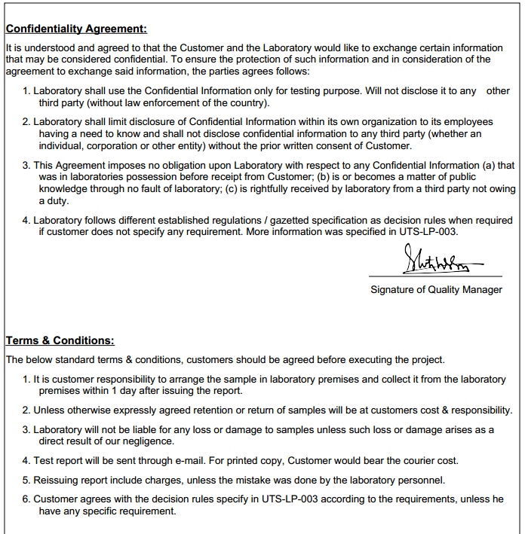

Important Links:
https://nusdat.com/

